
Patuakhali Science and Technology University

Faculty of Computer Science and Engineering

CCE 310 :: Software Development Project-I

Sessional Project Proposal

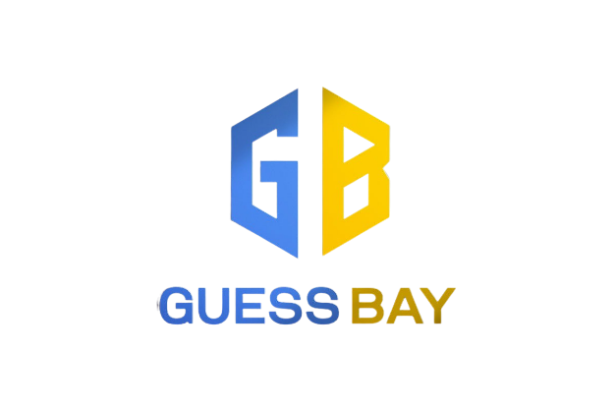

Project Title: GUESSBAY QUIZ APP
Submission Date: 27 November 2025

Submitted from, | Submitted to,
Md. Noushad Bhuiyan ID : 2102038,  Reg : 10165,  Semester : 5  (Level-3, Semester-1) | - Prof. Dr. Md Samsuzzaman  Professor,  Department of Computer and Communication Engi- neering,  Patuakhali Science and Technology University.  - Arpita Howlader  Assistant Professor,  Department of Computer and Communication Engi- neering,  Patuakhali Science and Technology University.

Contents
- Abstract 3
- Objectives 3
- Problem Statement 3
- Related Work 3
- Scope 4
- Methodology 4
  - Technology Stack 4
  - Design Principles 4
- Visual Models 5
  - Flow Chart Diagram 5
  - ERD (Entry Relationship Diagram) 6
  - Timeline (Gantt Chart) 6
  - UI Mockups 7
- Limitations 9
- Result 9
- References 9
- Weekly Report 10

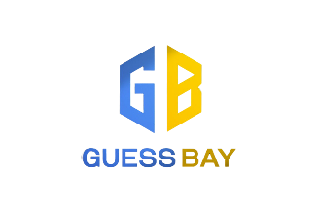

GUESSBAY

Abstract
Guessbay is a fast-paced mobile quiz game that combines the addictive one-question-at-a-time format of TikTok-style feeds with genuine prizes and token-based economy. Players answer user-created questions or Puzzle to win tokens, post their own high-stakes quizzes, puzzles, spin a daily wheel, and compete fairly in a transparent, escrow-protected environment.

Objectives
• Build a fun, free-to-start quiz app where anyone can win real money by answering just one question at a time.
• Let every player easily post their own questions, puzzle with real cash prizes and earn when others play.
• Give every new user 5 free tokens + daily wheel spins so they can win cash on day one without spending.
• Make the game super fair: prize money is locked in escrow and automatically paid to the winner.
• Create a viral loop with referrals, notifications, and fresh user-made questions every day.
• Earn steady revenue through small platform fees, token packs, and an optional $4.99 monthly subscription.

Problem Statement
Millions of people love playing quiz and trivia games on their phones, but almost all of them suffer from the same problems:
- Players can only answer questions — they can’t earn money by creating their own.
- Prizes are fake points, virtual coins, or tiny gift cards that feel worthless.
- The same boring questions repeat forever, and the feed quickly becomes stale.
- Many “real money” apps are unfair: the platform keeps the prize if no one wins, or they cheat with bots and impossible questions.
- New players have to pay real money from day one just to play, so most quit before trying.
- Creators have no way to earn from their knowledge and creativity.
Because of these issues, users get bored fast, don’t trust the game, and never come back — while talented people who could make amazing questions have no place to earn from them.
Guessbay solves all of this by turning every player into a creator and every correct answer into real cash, with a fair, transparent, and addictive system that keeps fresh questions flowing every second — completely free to start.

Related Work
- Quiiiz (quiiiz.com, 2025): A live head-to-head trivia platform where players compete in real-time quizzes on topics like general knowledge and sports, earning cash prizes from tournaments.
- Swagbucks Daily Trivia (Quora, 2025): Free daily quizzes across categories (e.g., history, entertainment) rewarding PayPal cash or gift cards.
- Quiz Cash (Google Play, 2025): Daily topic-based quizzes (GK, tech, sports) where correct answers earn redeemable coins for cash.
- Mega Quiz Gaming (HeyNau Games, 2025): Stream-integrated quizzes for Twitch/TikTok LIVE (e.g., "Guess the Logo" on gaming themes).
- Quizlet (NimbleAppGenie, 2025): Educational UGC platform for flashcards/quizzes; monetizes via premium subscriptions ($35/year) and corporate licensing.
- Riddle Quiz Maker (Riddle.com, 2025): Tool for creating monetized quizzes/polls with in

Scope
- Anyone can post a question with real cash prize (from their wallet).
- Players pay a small fee to answer, one question at a time (like TikTok feed).
- If someone answers correctly → they win the full prize instantly.
- If no one wins → half the fees go back, half split between creator & app.
- Everyone starts with 5 free tokens + daily wheel spins to play and win real money from day one.

Methodology

Technology Stack
The development of GUESSBAY will follow an agile methodology, allowing for iterative improvements and user feedback. Our technology stack will includes,

Frontend | Unity Canvas
Backend | Unity Monobehaviour
UI/ UX Design | Adobe Illustrator
Database | Firebase
Authentication | Firebase authentication
Hosting (web app) | Playstore(future)
CI/CD | GitHub
Table 1: Technology Stack for GUESSBAY

Design Principles
The design of GUESSBAY will adhere to the following principles,

Material Design | Following Google’s Material Design guidelines for a consistent  and modern UI/UX in Android
Responsive Design | Ensuring the application works seamlessly on various screen  sizes and orientations including web app.
User-Centric Design | Focusing on user experience and ease of use, with intuitive  navigation and clear UI elements.
Cross-Platform | Ensuring consistent functionality and design across Android,  iOS, and web platforms.
Documentation | Providing comprehensive documentation for developers and  users, including API documentation and user guides.
Table 2: Design Principles for GUESSBAY

Visual Models

Schema Diagram

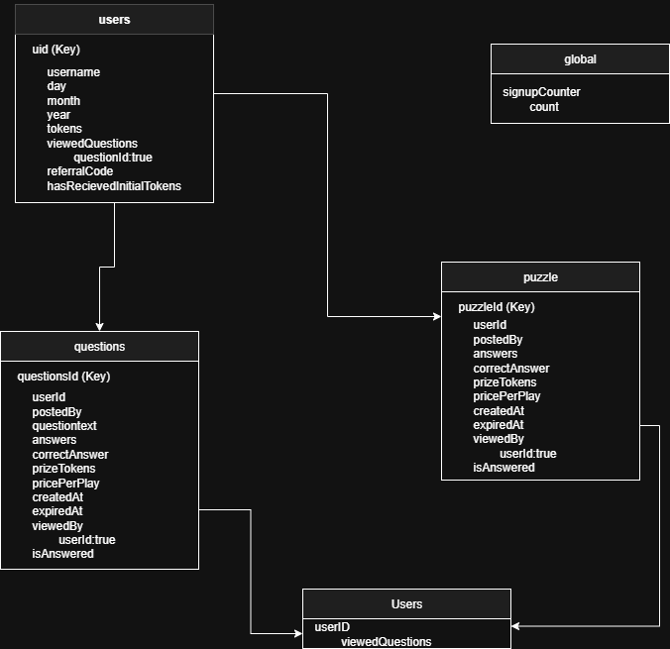

Figure 1: Schema Diagram of GUESSBAY Architecture

ERD (Entry Relationship Diagram)

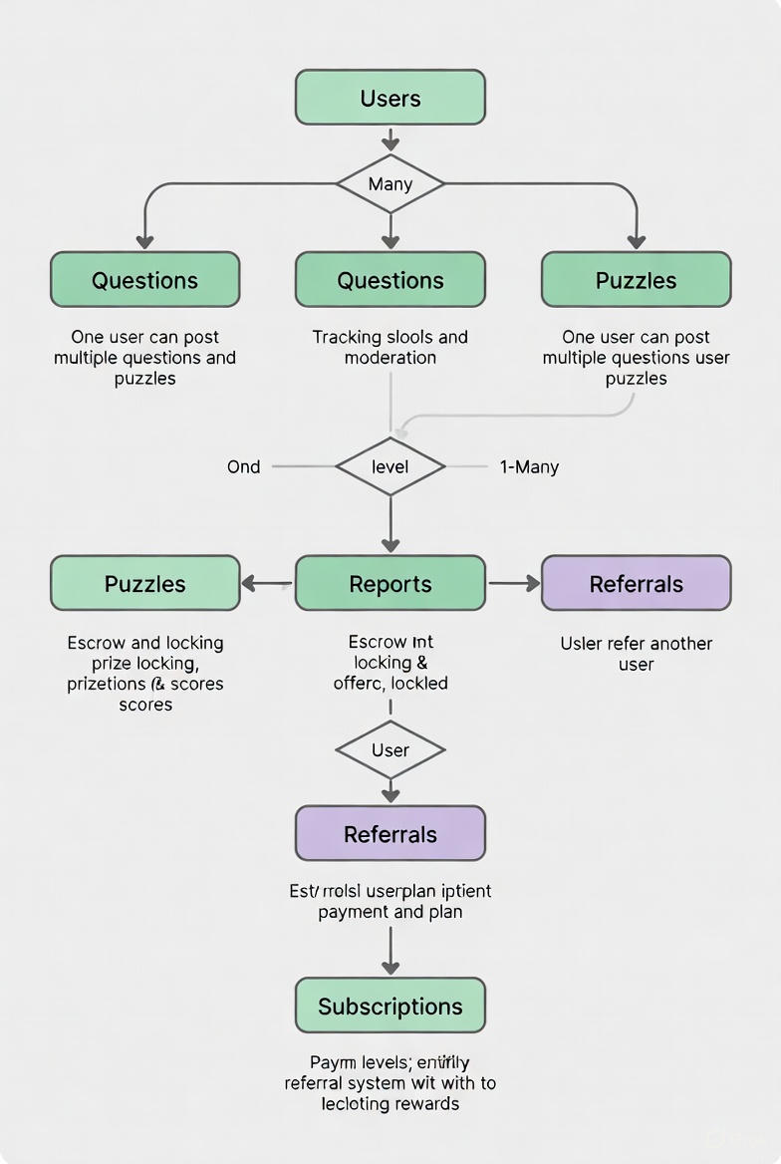

Figure 2: Entity Relationship Diagram of GUESSBAY

Timeline (Gantt Chart)
The base timeline for the development of GUESSBAY is as follows,

Task | Week  1-2 | Week  3-4 | Week  5-6 | Week  7-8 | Week  9 | Week  10 | Week  11 | Week  12
1. Project Setup + Login System | ✓ | ✓ | ✓
2. Token Wallet + Escrow Logic (Firebase) |  | ✓ | ✓
3.Question/Puzzle Posting + 4–15 Answers + Prize |  |  | ✓ | ✓
4.“For You” Feed – One Question/Puzzle, No Repeats |  |  |  | ✓
5. Gameplay – Timer, Power-ups, Win/Lose Flow |  |  | ✓ | ✓ | ✓
6.Daily Wheel + Rewarded Ads + Subscription |  |  |  |  |  | ✓
7. Notifications + Unread Badge + Referral |  |  |  |  |  | ✓ | ✓
9.Final Testing & Deployment |  |  |  |  |  |  |  | ✓
Table 3: Development Timeline of GUESSBAY

UI Mockups

Figure 3: UI Mockups of GUESSBAY

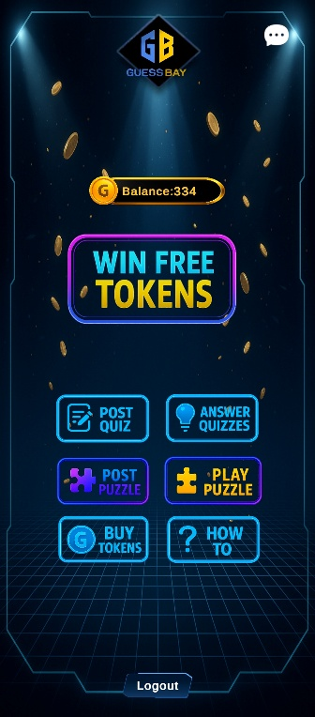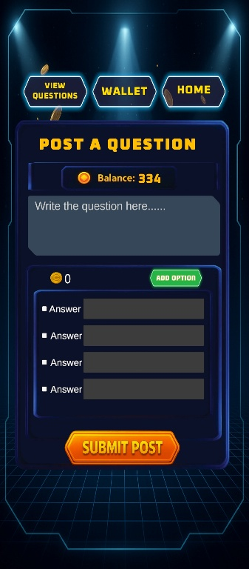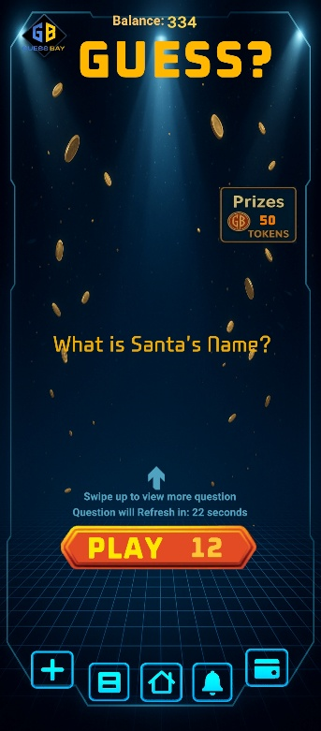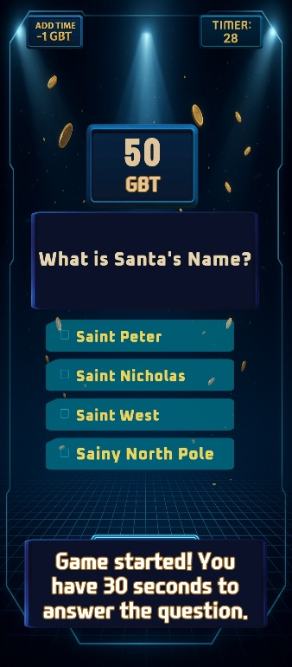

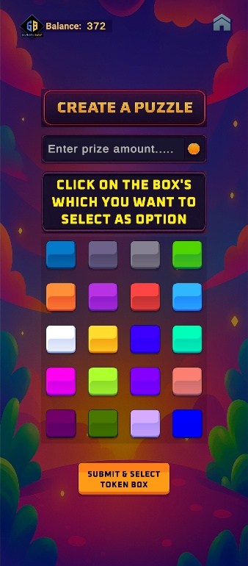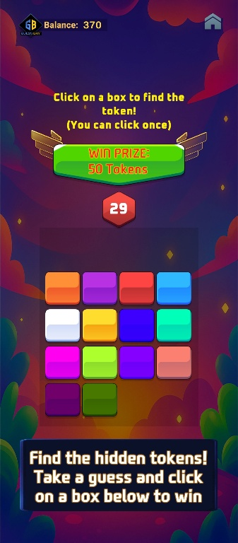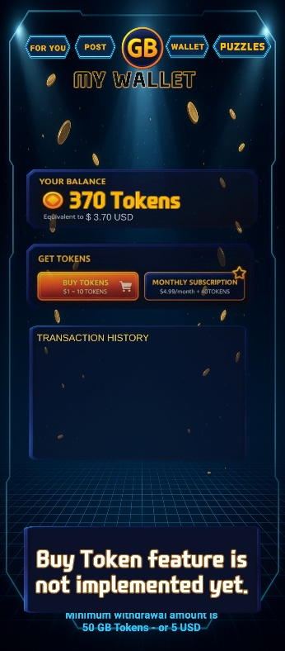

Figure 4: Add All the pages

Limitations
- Real-money gaming laws restrict launch in many countries (e.g. most US states, China, etc.) and require gambling licenses/KYC for withdrawals.
- High risk of fraud, botting, and cheating on user-posted questions, demanding constant moderation and anti-cheat systems.

Revenue depends heavily on users continuously funding new questions; if posting slows, content dries up and the entire economy stalls.

Result
The expected outcome of GUESSBAY is a fully functional, cross-platform application that allows users to manage their digital resources efficiently.

Weekly Report

No. | Date | Objective | Remarks
1 |  | Project proposal with initial R&D
2 |  | Signup and Login system
3 |  | Post question frontend and backend
4 |  | Post Puzzle frontend and backend
5 |  | Spin wheel
6 |  | Answer Quiz with security setup
7 |  | Play puzzle with security setup
8 |  | Admin Panel
9 |  | Notification System
10 |  | Security (No screenshot, app Close while open other tab)
11 |  | Report user who posts fake question
12 |  | Wallet system with payment integration
13 |  | Subscription (Normal, Premium)
14 |  | Sound system
15 |  | UI Animation

